PROJECT TITLE

ONLINE DOCTOR APPOINTMENT RESERVATION SYSTEM (ODARS)

Submitted in partial fulfillment of the requirement of

PG Diploma in Advanced Computing

By

Pranali Wandhare | 220940520061
Pranav Mirajgaonkar | 220940520062
Pranav Salwaru | 220940520063
Prasad Kunte | 220940520064
Prashant Tambe | 220940520065
Prashant Dhole | 220940520066
Pratiksha More | 220940520067
Priya Janghele | 220940520068
Pushkar Attarde | 220940520069
Rahul Deore | 220940520070



Centre for Development of Advanced Computing Juhu
Sept 2022

Abstract

The aim of this project is to create an online doctor appointment system. Nowadays we need to visit Doctor every now and then for some reason or another may it be a regular checkup or for a stomach bug or just for a follow up on the earlier treatment. But in our day-to-day hectic life getting a Doctor’s appointment has become a very difficult task. Customers have to call on Doctor’s reception to get a booking. Most of the times the time slot preferable to customers are not available or even Doctor himself is not available on the desired date. To resolve this problem statement, we have come up with online doctor appointment system. Here customers can be able to book doctor’s appointment anywhere in the world, this can be done via web browser. Doctors can also register to this system, view appointments and set available timeslots for appointment thereby making it more convenient for them.

Contents

Chapter | Contents | Page No.
1. | INTRODUCTION | 5
 | 1.1 Description | 6
2. | ANALYSIS MODELING | 7
  - Use Case Diagram

  - Class Diagram

  - Activity Diagram

  - Sequence Diagram
3. | DESIGN | 11
 | 3.1 ER Diagram

List of Figures

Fig. No. | Figure Caption | Page No.
1 | Use Case Diagram | 7
2 | Class Diagram | 8
3 | Activity Diagram | 9
4 | Sequence Diagram | 10
5 | E-R Diagram | 11

Chapter 1

Introduction

1. Product Perspective
This Doctor Appointment Reservation System is a self-contained system that allows patients to book appointment and doctors to manage appointments.

2. Product Functions
a. Provide an application that enables patients to book an appointment with any available doctor.
b. Doctors will be able to view their appointments and manage them properly.
c. Coordinate various calendars and finding available time slots for appointment.
d. Reserve equipment and rooms for appointment.
e. Alert patients in case there is an earlier available time slot.

Description

1. Login:
In order for the user (patient & doctor) to login, a username and password needs to be entered and this was implemented in a form that contained fields for name and password, when the form is submitted, the server checks the database if the email is available and the validity of the password, if the password and username is valid the user is redirected to the homepage else an error message is shown informing the user about the error. The login page also had a link that directs users that are not already registered to the registration page.

2. Registration:
In the case of registration the user has to provide personal information like name, email, password , verify password ,date of birth, address, gender, telephone all these information are to be inputted into their respective fields in a form, when the form is submitted the server first checks , if the password field is empty then if the password and verify password are the same, the system checks if the email is already registered if all these are correct, then a new user is created by inserting all these information in the database else an error message is displayed.

3. Home page:
This is the default page of the website i.e. the first page you see when you enter the website or after you login or register, this page is the most important it implements some functionalities specified in the requirements like:
Search: A search box is provided at the top of the page, with this you can search for doctors by first name or last name, when the search is submitted, the user is redirected to another page and a list of cars fitting that description is displayed.
The homepage contains a slider displaying some of the services offered by the business, it also has a section briefly discussing information about the business, departments in the business and founders of the business.

4. Doctor:
The doctor page displays the all the doctors available in the database, the doctor’s information is displayed, also there is a book appointment button on each doctor row, when the button is clicked on the user is directed to another page where the patient can book that particular doctor appointments can only be booked if the user is logged in else the user is directed to the log in page after which the user is redirected back to the destined/original page.

5. Appointment:
The reservation page displays a form with the fields Hospital, Department, date when this form is filled and submitted by the users, the system uses this information to search through the database and displays doctors fitting the users specification, when the user selects a doctor, he is directed to a page to book the doctor, appointments can only be booked if the user is logged in else the user is directed to the log in page after which the user is redirected back to the previous action page. After the user fills all necessary information and books the appointment a confirmation email is sent.

Chapter 2

Analysis Modelling

  - Use Case Diagram:

Fig 1. Use Case Diagram

  - Class Diagram:

Fig 2. Class Diagram

  - Activity Diagram:

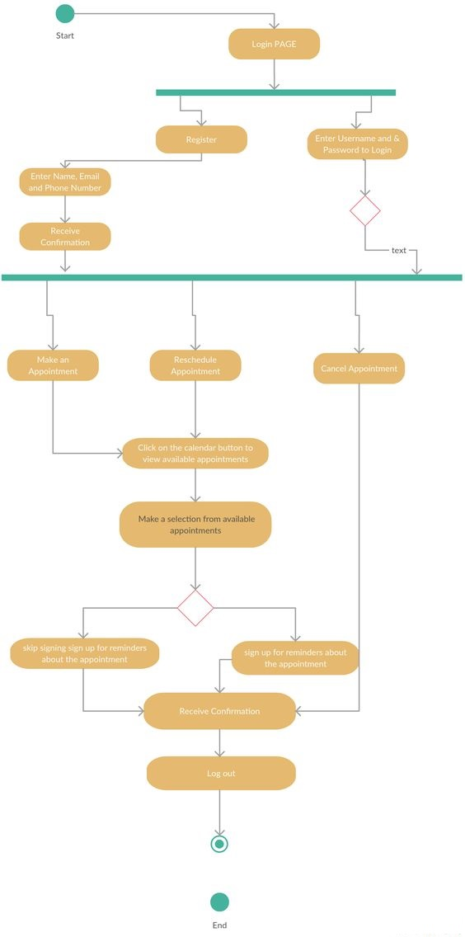

Fig 3. Activity Diagram

  - Sequence Diagram:

Fig 4. Sequence Diagram

Chapter 3

DESIGN

3.1 E-R Diagram:

Fig 5. E-R Diagram

